GA2 Instructions
By Tor Wager

This GA is good for optimizing sequences of trials with multiple parts per trial, where the delays between trials or between trial parts may or may not be allowed to vary. The exact timing of when each trial, and each subpart of each trial, occurs is optimized, as is the sequence of trial types.

- run model_setup_ui.m

This script asks you questions to help you construct your design. The main outputs that you need are two variables called mspec and conditions. Mspec (model spec) contains information about the run length, HRF, and TR. Conditions contains information about the trials – how many “parts” does the trial have (e.g., encoding-delay-retrieval) where are the onsets, how many. Both are structs (conditions is a vector of structs) that you can modify outside of run_model_setup.

When it asks for conditions, think of each “condition” as a trial type (e.g., spatial vs. object memory), where each trial type can have multiple parts. Example questions and responses for this script are below, with explanation. Responses you type in are shown in red. Comments on what’s happening are at the right.

* warning – this may not be a very user-friendly script, and if you mess something up typing things in, you may have to start again. You can also edit mspec and conditions manually, once they’re created, to change things.
>> model_setup_ui  Model setup user-interface: for specifying a design matrix.  by Tor Wager, version a1  ________________________________________________  Enter TR in s 2  Enter run length in s 300  Condition setup:  Press return when asked for onsets for a condition to exit.  ________________________________________________ | Run the script. This is what you see.
Onsets for condition 1 in s [1 20 40 60 80 100 120 140 170 200 230 260]  Parts for condition 1: enter 1 or num parts 2  Onsets for condition 1 part 1 relative to: 1 for start of trial, 2 for prev. part 1  Onsets in s for condition 1 part 1 from start of trial 5  Stimulation length in TRs for condition 1 part 1 2  Convolve condition 1 part 1 with canonical HRF? 1/0 1 | Onsets is a row vector in brackets, in seconds, determining fixed onset times (every 20 s here).  Parts is how many subparts (2). Define the onsets at 5 s from the start of the trial, include 2 TR’s worth of onsets (2, one per TR) and convolve.
Onsets for condition 1 part 2 relative to: 1 for start of trial, 2 for prev. part 2  Onsets in s for condition 1 part 2 from previous part [5 8]  Stimulation length in TRs for condition 1 part 2 1  Convolve condition 1 part 2 with canonical HRF? 1/0 1 | Second part of Condition 1 trial. Onsets at 5-8 s after onset of previous part, 1 TR stimulation, also convolve.
Onsets for condition 2 in s 10:20:240  Parts for condition 2: enter 1 or num parts 1  Onsets for condition 2 part 1 relative to: 1 for start of trial, 2 for prev. part 1  Onsets in s for condition 2 part 1 from start of trial 0  Stimulation length in TRs for condition 2 part 1 5  Convolve condition 2 part 1 with canonical HRF? 1/0 0  Estimate shape-free HRF for condition 2 part 1 ? 1 or TP to estimate 10 | Second condition (trial type). 10:20:240 specifies onsets of trials in seconds. You could also enter [1 4; 6 20]; This specifies that you want variable trial onsets and lengths with optimized placement. 1 4 indicates a start delay before the trial between 1 and 4 s, with a trial length of 6 – 20 s.  One part, onsets at 0 s from start of the trial, stimulation epoch lasting for 5 TRs. Do not convolve – instead, estimate deconvolution HRF for 10 TRs (20 s)
Onsets for condition 3 in s <return> | Exit the program.

- Let’s build the design matrix we just specified.
We’ll use the function construct_model.m
>>[X,paramvec] = construct_model(mspec,conditions,[]);

To get the event onset times in seconds for each event type, we can use:
>> [evtonsets,paramvec] = paramvec2onsets(mspec,conditions,[]);

OR, if we already have a paramvec cell array created (see below), we can use:
>> [evtonsets,paramvec] = paramvec2onsets(mspec,conditions,paramvec);

Paramvec, the third input, is a struct that specifies exactly what any random values are. In our design, the onset for Condition 1 part 2 can vary between 5 – 8 s. For a given instantiation, some value will be chosen, and that’s stored in paramvec. The GA uses the values in paramvec to optimize the parameters you’ve selected as variable. So in this case, the GA would optimize the timing of the onset for Condition 1 Part 2 on each trial, with the criterion being an estimable model. X is the design matrix. Here it is:

>> imagesc(X); colormap gray
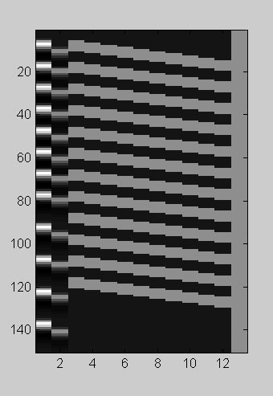

We have condition 1, part 1 in the first column, starting 5 s after the onset times we entered for the trial start and lasting for 2 TRs, convolved. C1 part 2 is in column 2, starting 5-8 s after the end of stimulation (? What exactly is it relative to? I forgot.) for part 1 and lasting for 1 TR (convolved). Condition 2 is 5 TRs long in stimulation, not convolved, and there is one column per TR for 10 TRs, estimating the mean signal for 10 TRs following stimulus onset.

Oops, we made a mistake. We wanted 1 TR of stimulation for condition 2. Let’s change it to 1 TR:

>>conditions(2).stimlength = 1;

Let’s also change the delay interval for part 2 following part 1 of Condition 1.

>> conditions(1).subcond(2).onsets = [2.5 15];

So, the first (1) references the trial type, .subcond references the subpart field, and the (2) references which subpart we want. .onsets is the onset field, and we notice that they numbers are not the [5 8] we entered before. They’ve been converted to TRs, so we have to enter what we want in TRs as well.

…and then re-construct the model.

>> [X,paramvec] = construct_model(mspec,conditions,[]);

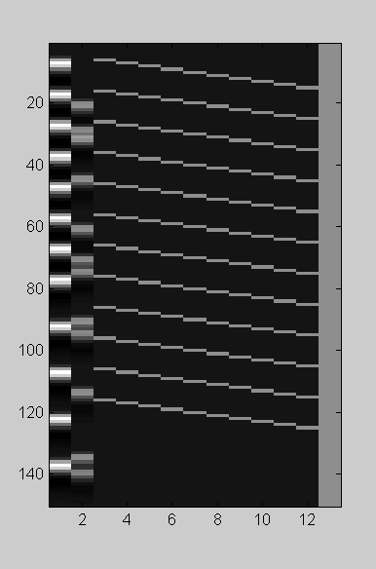

Now, say we want to get rid of the second condition and the 2nd subpart of the first condition :

>> conditions(2) = [] ;
>> conditions(1).parts = 1 ;

% This doesn’t eliminate part 2, just doesn’t use it in model building

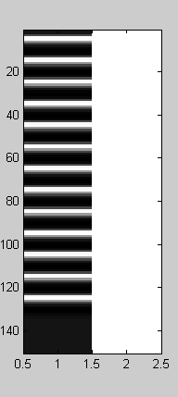

Now, say we want to randomize and optimize the onsets of these single trials in order to detect the main effect of this single event. So far, we have fixed sequence of trial onsets. What we want to do is vary it randomly, by changing :

>> conditions(1).onsets = [0 0 ; 6 30] ;

This tells us that the trials should have an onset delay varying between 0 and 0 seconds (so no onset delay), and a length between 6 and 30 TRs. Careful here : because we’ve changed this at the command line, we’re working in TRs. If we enter this for the onsets in model_setup_ui, we enter it in seconds, and it automatically divides by the TR.

So, now our design looks like this :

>> [X,paramvec] = construct_model(mspec,conditions,[]); figure;imagesc(X); colormap gray

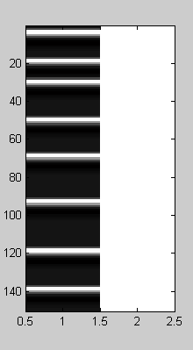

- Run the GA.

The GA will optimize anything you specify as variable.

>> [evtonsets,X,bestp,meff] = ga2(gensize,numgen,conditions,mspec);

gensize is the size of generations, in designs (try 500)
numgen is the number of generations.
Conditions and mspec are the output from model_setup_ui.m

INTERPRETING THE RESULTS OF THE GA:
(how do you figure out which stimuli to present when?)

The GA, when it completes, will automatically print lists of onset times in seconds for each event type. To get them after the fact, look in the first output argument of ga2.m, called evtonsets in the example above. It contains the onsets for each event type in a cell array, accessible using evtonsets{i}, in s from the start of the run.

To recover these things using other outputs of the ga (in particular the variable bestp) and the conditions and mspec structures you put into the ga, use the function paramvec2onsets.m:

>> [evtonsets] = paramvec2onsets(mspec,conditions,bestp);

Also provided is a comparison of your design to 1000 random designs, using A and D optimality considerations. You can use the graph produced at the end of the GA run in interpreting how good your design is relative to other, random designs. The figure below shows a typical result in optimizing for HRF estimation of a single trial type up to 30 s (15 TRs of estimation) after 1.5 minutes of GA run time:

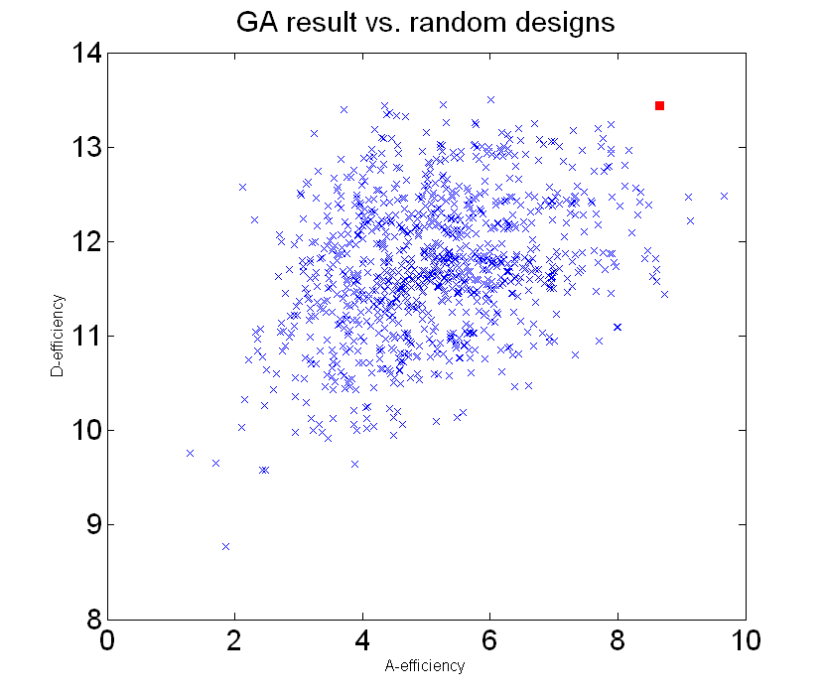

A- vs D-optimality

A-optimality minimizes the variance of each parameter estimate in your model (in ga2.m, each column or predictor in the design matrix). However, it does not take into account colinearity between the parameter estimates for different columns. D-optimality does that, by maximizing the determinant of the Fischer Information Matrix (X’X). It maximizes the volume of the space covered by the predictors.

Additional information about bestp:

Bestp contains the stimulus parameters of the best design from the GA output. It’s a cell array, with one cell per part of a trial or condition.
>>bestp
bestp =
[1x17 double] [1x17 double] [1x17 double]

We can access this by typing >>bestp{i}, where I refers to the cell.

The cells in this example—with 1 trial type containing two parts—are, in order, 1) trial onsets for condition 1, 2) onsets for event 1 of trial 1 relative to the trial onset, 3) Onsets for event 2 of trial 1 relative to the onset of event 1. These numbers, all in TRs, tell you when to present the stimuli. Bestp contains all the onsets for every timing parameter you specified as VARIABLE—that is, to be optimized—in the GA.

>> bestp{1}
ans =
0 12 24 39 37 58 63 77 86 97 111 119 128 122 130 135 161

Trial onsets at the above TRs.

>> bestp{2}
ans =
3 3 3 3 3 3 3 3 3 3 3 3 3 3 3 3 3

First event occurs 3 TRs after the trial onset in all cases. If this is a fixed parameter, it’s not usually given a cell in bestp – you just read it from the “conditions” structure, the strucuture output from model_setup_ui that you gave as input to the GA. So this is the exception, for a fixed parameter to appear in bestp; it might happen if you specified a variable “range” of zero, e.g., [3 3] as input. See below for an example of how to find fixed parameters in the conditions structure.

>> bestp{3}
ans =
5 4 5 3 3 5 3 3 3 3 5 5 3 3 3 3 5

Event 2 onsets at these TRs, relative to the onset of Event 1.

Another example:

First, here’s the input:
>> model_setup_ui
Model setup user-interface: for specifying a design matrix.
by Tor Wager, version a1
___________________________________________________________
Enter TR in s 2
Enter run length in s 360
Condition setup:
Press return when asked for onsets for a condition to exit.
___________________________________________________________
Onsets for condition 1 in s 0:20:240
Parts for condition 1: enter 1 or num parts 2
Onsets for condition 1 part 1 relative to: 1 for start of trial, 2 for prev. part 1
Onsets in s for condition 1 part 1 from start of trial [5 10]
Stimulation length in TRs for condition 1 part 1 1
Convolve condition 1 part 1 with canonical HRF? 1/0 1
Onsets for condition 1 part 2 relative to: 1 for start of trial, 2 for prev. part 2
Onsets in s for condition 1 part 2 from previous part 4
Stimulation length in TRs for condition 1 part 2 1
Convolve condition 1 part 2 with canonical HRF? 1/0 1
Onsets for condition 2 in s [0 0;10 30]
Parts for condition 2: enter 1 or num parts 1
Onsets for condition 2 part 1 relative to: 1 for start of trial, 2 for prev. part 1
Onsets in s for condition 2 part 1 from start of trial 0
Stimulation length in TRs for condition 2 part 1 1
Convolve condition 2 part 1 with canonical HRF? 1/0 1
Onsets for condition 3 in s

Now, we run the GA:

>> [evtonsets,X,bestp,meff] = ga2(20,5,conditions,mspec);
Gen 1: best eff is 32.2416, model 14, time = 0.10, elapsed = 1
Gen 2: best eff is 32.6057, model 20, time = 0.07, elapsed = 1
Gen 3: best eff is 32.8596, model 13, time = 0.10, elapsed = 1
Gen 4: best eff is 32.9811, model 13, time = 0.06, elapsed = 1
Gen 5: best eff is 34.0233, model 15, time = 0.06, elapsed = 1

>> bestp
bestp =
[1x13 double] [1x18 double]

Notice that we have only two VARIABLE conditions that are optimized by the GA, and so get specific lists of event timings in bestp. These are 1) Onsets for event 1 from start of trial. So the start of the trials is fixed, 0:20:240 = every 20 s. The timings, in TRs, of when to present the first event relative to the trial onset are shown below:

>> bestp{1}
ans =
3 3 4 3 4 3 3 3 3 4 3 5 4

The other VARIABLE parameter is the onsets for Trial Type (condition) 2. These are shown in the next cell. Thus, if you go through the input into the GA that you put in with model_setup_ui, every time you specify a variable range of timings that should be optimized, you’ll get a cell in bestp that describes what those best timings should be.

>> bestp{2}
ans =
0 14 29 39 48 56 71 85 86 93 108 114 122 131 141 156 154 162

Again, these onset times are in TRs, and since they code for condition onsets, they’re from the start of the experiment. 0 is the first TR of scanning. Next, we can read other parameters from the conditions structure:

>> conditions(1)
ans =
onsets: [0 10 20 30 40 50 60 70 80 90 100 110 120] % onsets in TRs
parts: 2 % two events within this condition
subcond: [1x2 struct]
stimlength: 4.5000 % stimulation is 4.5 TRs long (only used
% if there are no “subcond” events, and
% the condition onsets ARE the events)

>> conditions(1).subcond(1) % specs for the first event type (subcond)
ans =
rel_to: 1 % 1 is relative to start of trial, 2 is rel. to
% previous event type (subcond)
onsets: [2.5000 5] % variable onsets (look in bestp)
stimlength: 1 % stimulus length
convolve: 1 % convolve this event type with HRF
hrfest: [] % no. of time points for HRF est, if not
% convolving
>> conditions(1).subcond(2)
ans =
rel_to: 2
onsets: [2 2 2 2 2 2 2 2 2 2 2 2 2] % ah, this means we present event type 2
% 2 TRs after the onset of Event type 1
% this info is not in bestp
stimlength: 1
convolve: 1
hrfest: []

Once you know these things, you can construct when you should present each event type relative to the start of the experiment—or you can use this information directly in programming your task.

Constrained trial orders

The default in GA2 is to allow events of different trials to overlap; that is, an event in Trial Type (condition) 2 could begin before the last event in Trial Type 1. There is an option to prevent this from happening, however. Just enter an additional argument, the number 1, in the ga2.m, construct_model.m, and paramvec2onsets.m functions. An example is shown below.

[X,pv2] = construct_model(mspec,cond2,[],[1 5]);figure;imagesc(X);
[evt,pv2] = paramvec2onsets(mspec,cond2,pv2,[1 5]);

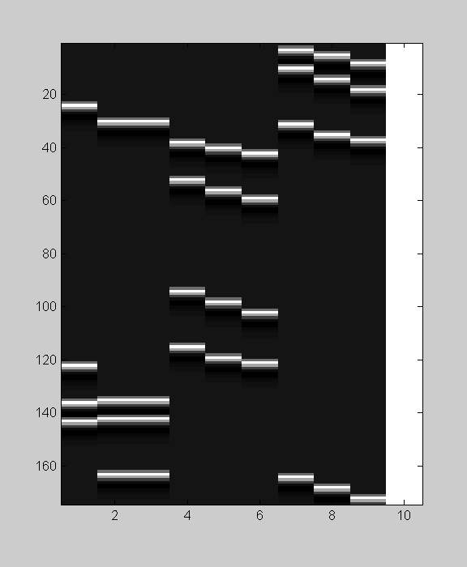

Notice that in this figure, two columns are completely colinear – yet there is still a positive efficiency for this design. Why did this happen? There wasn’t enough spacing between trials, and so the events for the 2nd and 3rd columns are pushed up against the start of the next trials. The GA will find the best solution it can given the constraints you impose, but there’s no guarantee that the constraints you’ve chosen are themselves optimal!

Good luck!

Tor

Another example with constrained trial onsets, two trial types:

% set the trials to be 8 – 16 s between successive trial onsets (TR =1.5)
conditions(1).onsets = [0 0; 8 16] ./ 1.5;
conditions(2).onsets = [0 0; 8 16] ./ 1.5;

% build design and plot it
[evtonsets,X2,pv2] = paramvec2onsets(mspec,conditions,[],[1 5]);
[X3,d,out] = plotDesign(evtonsets,[],1);
[X3,d] = plotDesign(evtonsets,[],1,2,cat(2,conditions.stimlength));

% check min difference in s between onsets (min is at least 7.5 here because of
% rounding
tmp = sort([evtonsets{1}; evtonsets{2}]); min(diff(tmp))

% check whether we get the same results from construct_model and paramvec2onsets
[X,pv] = construct_model(mspec,conditions,pv2,[1 5]);
[evtonsets,X2,pv2] = paramvec2onsets(mspec,conditions,pv,[1 5]);

